Viewing Plane

📘 Definition
# Source: AI Source: Provided by: [Data Path: Persons Table -> ID Column: 1, Name_En Column: Motasem Essam] -> From: [ChatGPT] on [5/2/2026]
A Viewing Plane (also called the projection plane or image plane) is the flat surface in computer graphics where a 3D scene is projected to form a 2D image.
It is like an invisible screen in front of the camera where everything gets drawn.

🖥️ How the viewing plane works
# Source: AI Source: Provided by: [Data Path: Persons Table -> ID Column: 1, Name_En Column: Motasem Essam] -> From: [ChatGPT] on [5/2/2026]
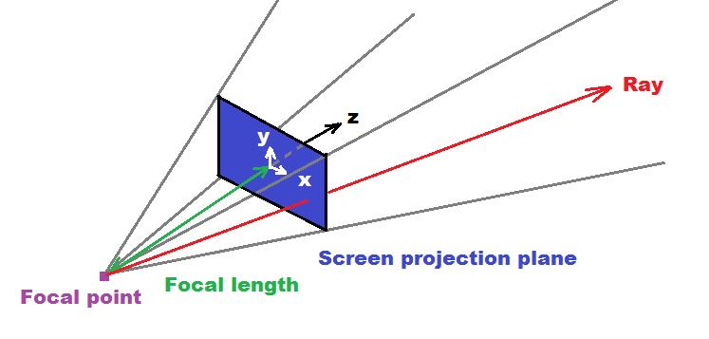
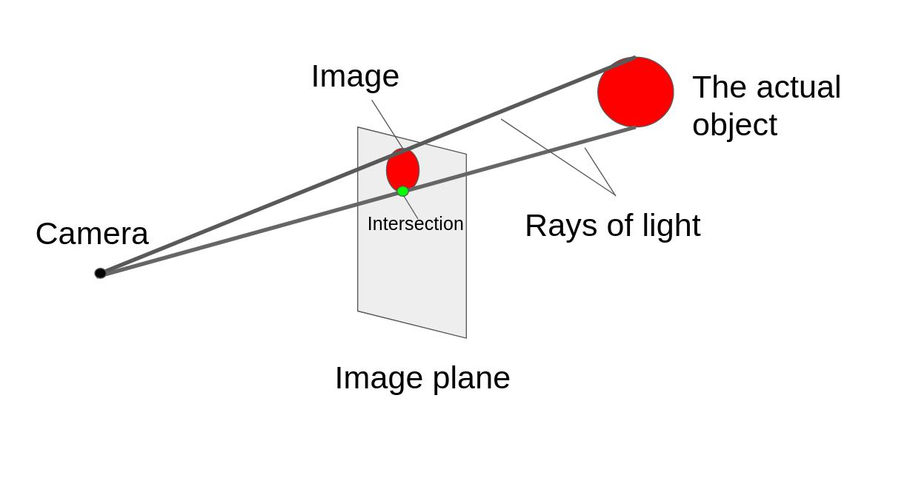
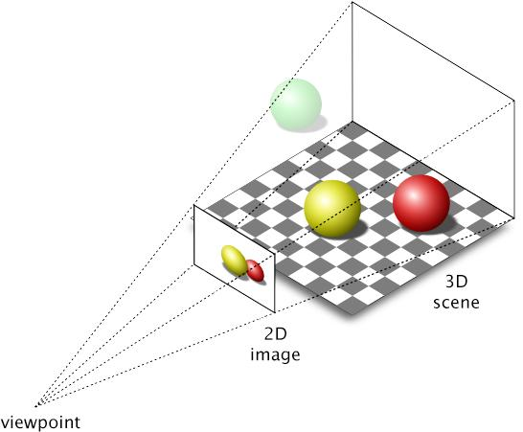
- A camera looks at a 3D scene
- Light rays from objects pass through the scene
- These rays intersect the viewing plane
- The result is a 2D image (what you see on screen)

🧠 Simple example
# Source: AI Source: Provided by: [Data Path: Persons Table -> ID Column: 1, Name_En Column: Motasem Essam] -> From: [ChatGPT] on [5/2/2026]
Think of:
- 📷 A camera sensor or film inside a real camera
- 🖥️ A computer screen where the image appears
The viewing plane is where the 3D world gets “flattened” into a picture.

🎮 Why viewing plane is important
# Source: AI Source: Provided by: [Data Path: Persons Table -> ID Column: 1, Name_En Column: Motasem Essam] -> From: [ChatGPT] on [5/2/2026]
- 🎮 Converts 3D scenes into 2D images in games
- 🎬 Used in rendering movies and animation
- 🧑‍💻 Helps define how objects are displayed on screen
- 📐 Works with perspective and projection systems

⚙️ Key features
# Source: AI Source: Provided by: [Data Path: Persons Table -> ID Column: 1, Name_En Column: Motasem Essam] -> From: [ChatGPT] on [5/2/2026]
- 📏 Flat 2D surface
- 📷 Receives projection from the camera
- 🧩 Turns 3D world into a 2D image
- 🎯 Determines final screen output

🚀 In short:
# Source: AI Source: Provided by: [Data Path: Persons Table -> ID Column: 1, Name_En Column: Motasem Essam] -> From: [ChatGPT] on [5/2/2026]
Viewing Plane = the imaginary flat surface where a 3D scene is projected to create a 2D image for display.

